**Sensor Nodes Laboratory**

**Milestone Report 1**

**Read out front-end circuit**

Sebastian Thekkekara and Nitish Nagesh, Department of Electrical and Computer Engineering,

Technical University of Munich, Arcisstr. 21, 80333 Munich, Germany

**Introduction:**

The goal of the sensor nodes laboratory is to develop a fully functional prototype of a wireless sensor node by the end of the summer semester 2019.

To achieve this goal, a temperature sensing mechanism has been taken into consideration using a resistance temperature detector (RTD). The tasks include

1. Developing a read-out front-end circuit
2. Implementing a communication interface between the read-out circuit and wireless communication board
3. Encapsulating the data from a server and visualising it on a terminal

In the first few weeks, we spent time on understanding the basics of Analog-to-Digital Converters (ADCs), different types of filters and filter design principles. We also installed Programmable System-On-Chip (PSoC) Creator by Cypress Semiconductors and Code Composer Studio (CCS) by Texas Instruments (TI). The lectures helped us get a better overview of the project requirements.

This report details the components used, the preliminary circuit design and implementation of the front-end circuit for the temperature sensor.

**Components:**

In this project, the following components are used - PSoC 5LP, Pt 1000, Breadboard, Resistors, Capacitors, Op-amps and TI Launchpad

**Circuit Design and Implementation:**

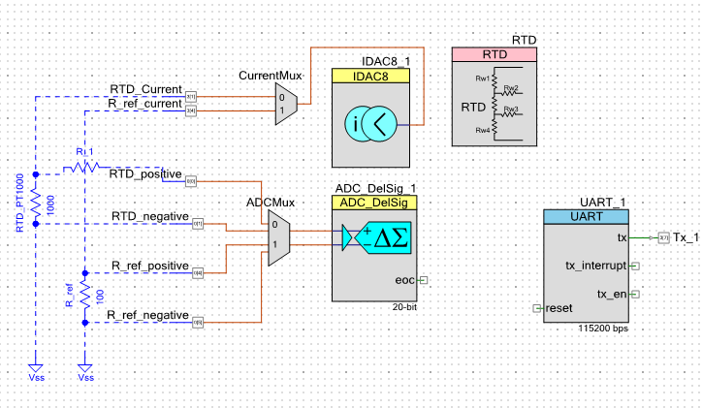

**Fig. 1. PSoC circuit design**

The platinum (Pt) resistor Pt 1000 bearing a resistance of 1000 ohms is connected to an ADC multiplexer (MUX). According to the application note [1], a reference resistor of 0.1% of the total resistance i.e. 100 ohm is also connected to the MUX. The output of the MUX is sent to the delta-sigma ADC. The current across the Pt 1000 resistor and reference resistor is measured via current probes and sent to the current MUX. The MUX output is connected to an IDAC. The communication to the microcontroller is achieved using Universal Asynchronous Receiver/Transmitter (UART) communication protocol. Only the resistors are external components while the remaining components are in-built in the PSoC.

The 2-wire RTD measurement is used as there are two probes of the PT1000 which are used for analysis. To obtain higher accuracy, 3-wire and 4-wire RTD configurations can also be used. Higher accuracy implies errors due to wire resistances and voltage drop across external resistances does not affect the voltage measured across the RTD. In this project, a 2-wire RTD is implemented for the sake of convenience.

The reference resistance is chosen as 0.1% of the RTD resistance such that it does not load the IDAC, has same voltage range as RTD and is similar to the resistance of RTD at temperature being measured. It is beneficial to have the reference resistor and RTD in the same circuit to cancel out non-linearities.

The current through IDAC should be as low as possible to avoid power dissipation and measurement errors due to self-heating. If more current is passed through RTD and reference resistor, more ADC range can be used. PSoC 5LP has an ADC input range of +/- 1.024 V. Hence, there is a trade-off between resolution and self-heating error. Self-heating can be avoided by disconnecting the IDAC when not being used and turning it back on while measuring current.

**Results and Discussion:**

In this step, we completed the preliminary design of the PSoC circuit. However, there were some errors while implementing the code with respect to the multiplexer and RTD block. The range of values for ADC was also decided on a preliminary basis. We were able to observe the behaviour of the PSoC and prepare well for the next stages of the project.

**References:**

[1] [**http://www.cypress.com/AN70698**](http://www.cypress.com/AN70698)**.**